GIT MERGE

\* Merging is git's way of putting a history back together again.the git merge command lets you take the independent

lines of development created by git branch and integrate them into a single branch.

How it works?

\*git merge will combine multiple sequence of commits innto one unified history.in the most frequent use cases ,git merge is used to combine two branches .

3-WAY MERGEES

The reason it is called a 3 way merge is because the merge commit is based on three different commits.

\* In 3-way merge, git uses tree commits to generate the merge commit two branch tips and their common anchestor.

EXAMPLE -> in this example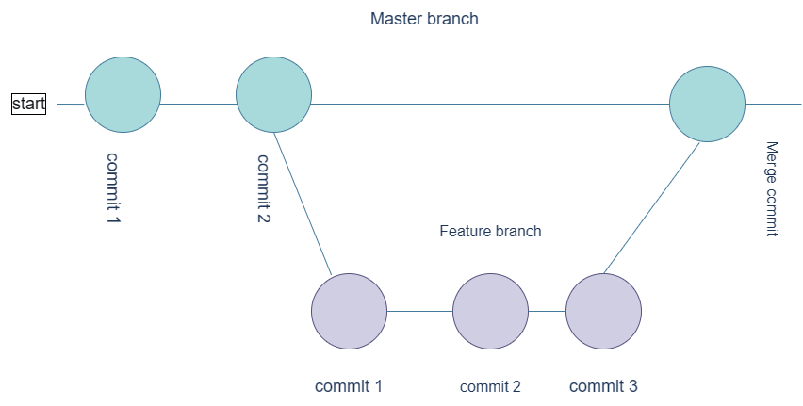ther are two commit for master branch and three commit for feature branch